**[DOING PHYSICS WITH PYTHON](https://d-arora.github.io/Doing-Physics-With-Matlab/)**

**COMPUTATIONAL OPTICS**

**RAYLEIGH-SOMMERFELD 1**

**DIFFRACTION INTEGRAL CIRCULAR APERTURE:**

**HERMITE-GAUSS BEAM PROPAGATION**

**Ian Cooper**

Please email me any corrections, comments, suggestions or additions: **matlabvisualphysics@gmail.com**

[**maitreyee.roy@unsw.edu.au**](mailto:maitreyee.roy@unsw.edu.au)

**DOWNLOAD DIRECTORIES FOR PYTHON CODE**

[**Google drive**](https://drive.google.com/drive/u/3/folders/1j09aAhfrVYpiMavajrgSvUMc89ksF9Jb)

[**GitHub**](https://github.com/D-Arora/Doing-Physics-With-Matlab/tree/master/python)

**emRSHGXY.PY**

Propagation of a Hermite-Gauss beam from a circular aperture. The irradiance in an observation XY plane is computed by solving the RS1 diffraction integral.

Links 🡪 [**Hermite polynomials and Hermite-Gauss functions**](https://d-arora.github.io/Doing-Physics-With-Matlab/pyDocs/emHG01.pdf)

[**RS1 diffraction integral**](https://d-arora.github.io/Doing-Physics-With-Matlab/pyDocs/emRS01.pdf)

**Hermite–Gaussian (HG) beams** have significant potential to improve the capacity of free-space optical communication. Free-space optical communication has the advantages of high bandwidth, high data rate, low energy consumption and high confidentiality and is considered a promising technology for next-generation communication.

So, this article will discuss the propagation of a HG beam from a circular aperture. A higher-order HG beam can form a multiple-spot pattern for the irradiance rather than a single spot as generated by

lowest-order Gaussian beam. Also, a HG beam has unique orthogonal spatial modes and well-preserved irradiance distribution in free-space propagation.

**Hermite-Gauss circular aperture functions** and are given by



where *m* and *n* represent the transverse mode numbers, *H* are the Hermite-Gauss polynomials and  is a characteristic mode width. For a circular aperture *a*



In particular, for *m* = *n* = 0, the HG beam is reduced a **Gaussian beam** (the lowest-order TEM00 beam). For the Gaussian beam, *w*0 denotes the TEM00 beam waist at the aperture and *w* denotes the TEM00 spot size in the XY observer place



**SIMULATIONS**

The Python Code **emRSHGXY.py** is used for the simulations to calculate the XY irradiance pattern at a given distance between the aperture and observation plane for different values of the orders *m* and *n*. A summary of the simulation parameters is displayed in the Console Window.

nQ = 201 nP = 201

wavelength wL = 633 nm aperture radius a = 0.400 mm

m = 1 n = 1

zP = 1.00 m

Imax = 1.06e+24

Execution time 114 s

For the TEMmn plots below, the irradiance patterns have been scaled , so that the weak minor maxima are more visible .

**TEM00**

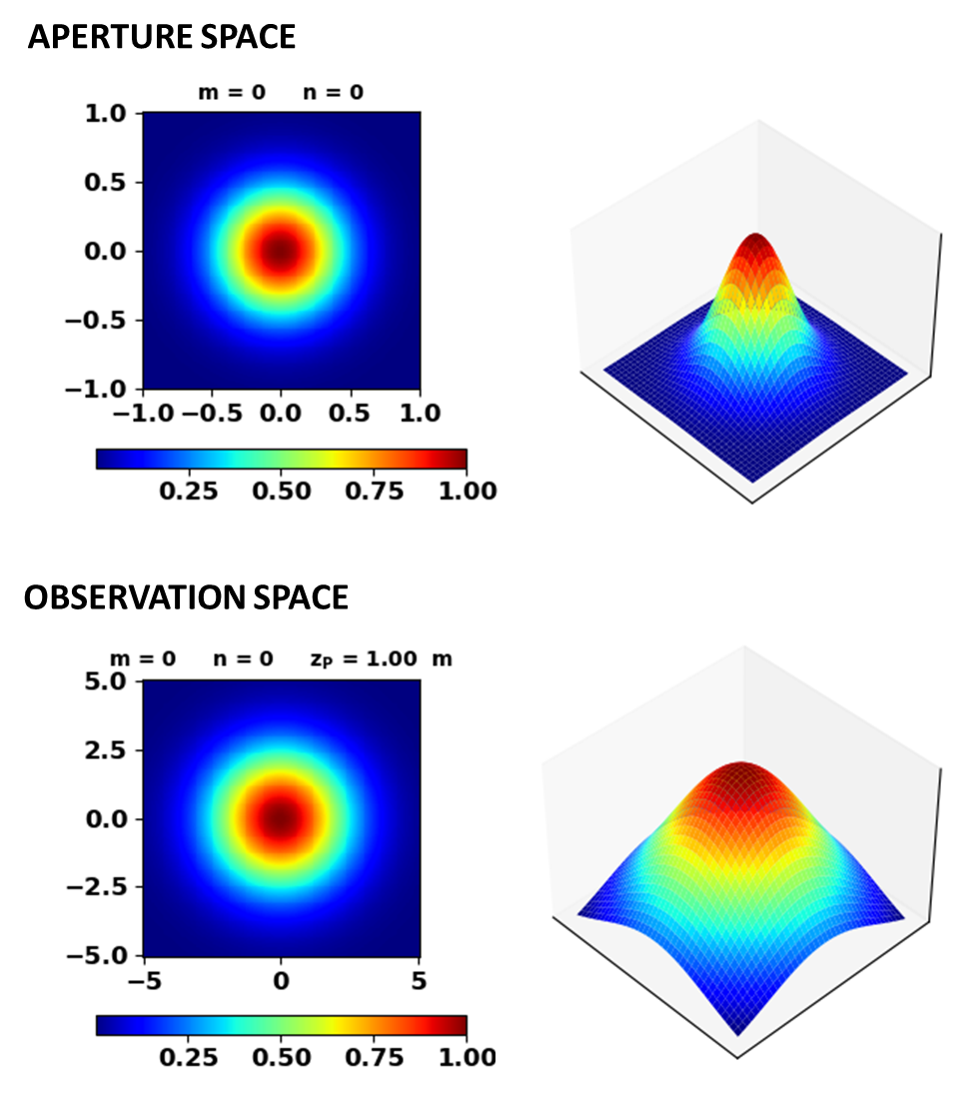

**TEM10**

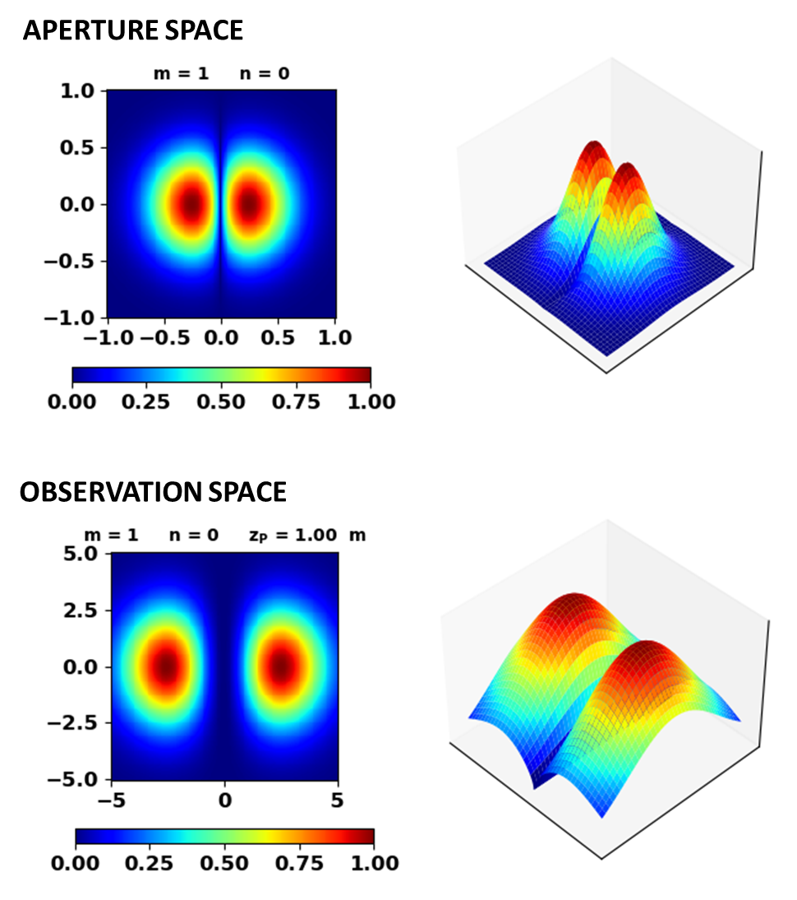

**TEM11**

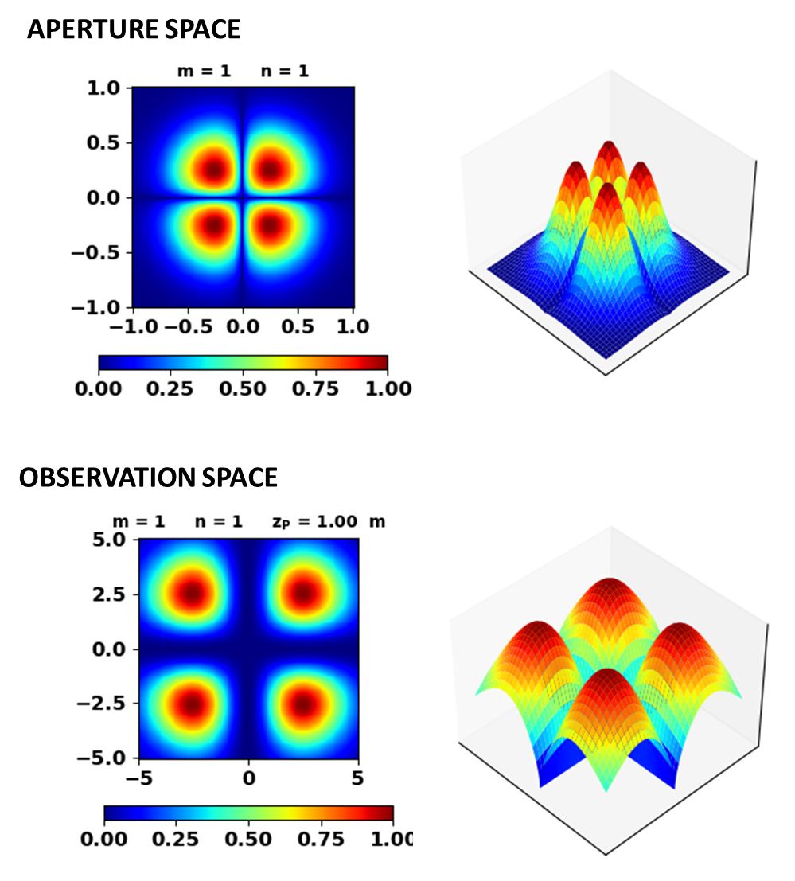

**TEM20**

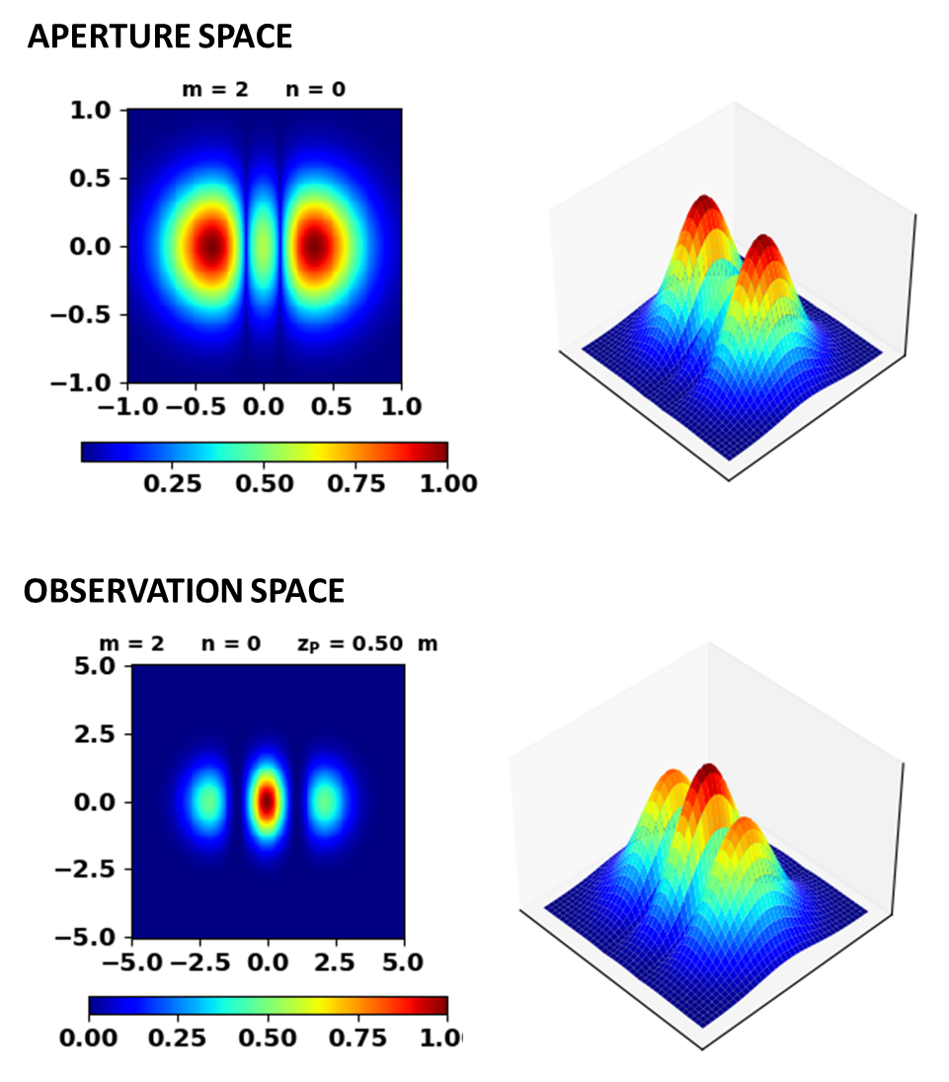

**TEM21**

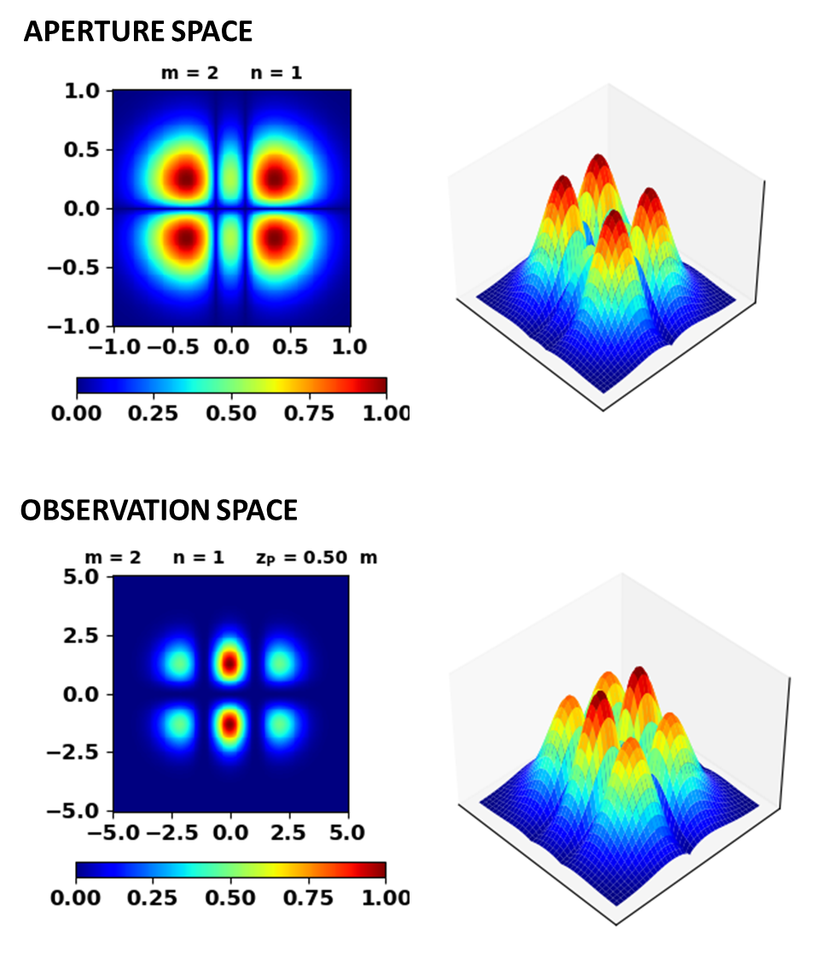

**TEM22**

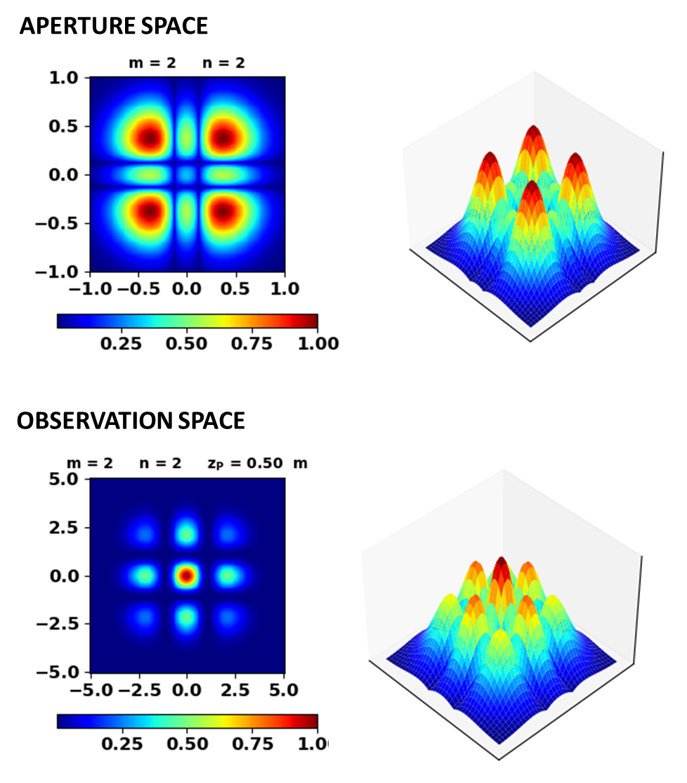

**TEM30**

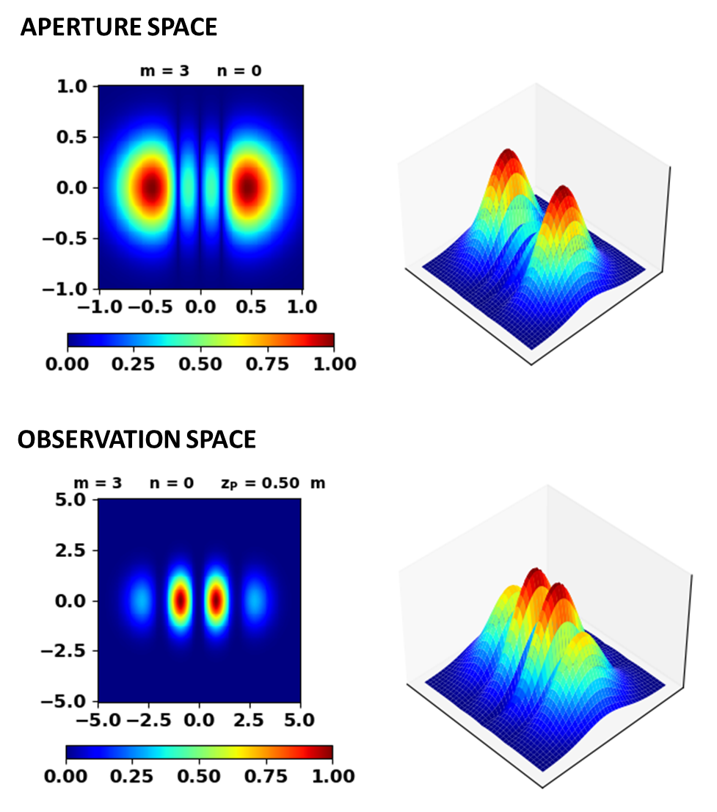

**TEM31**

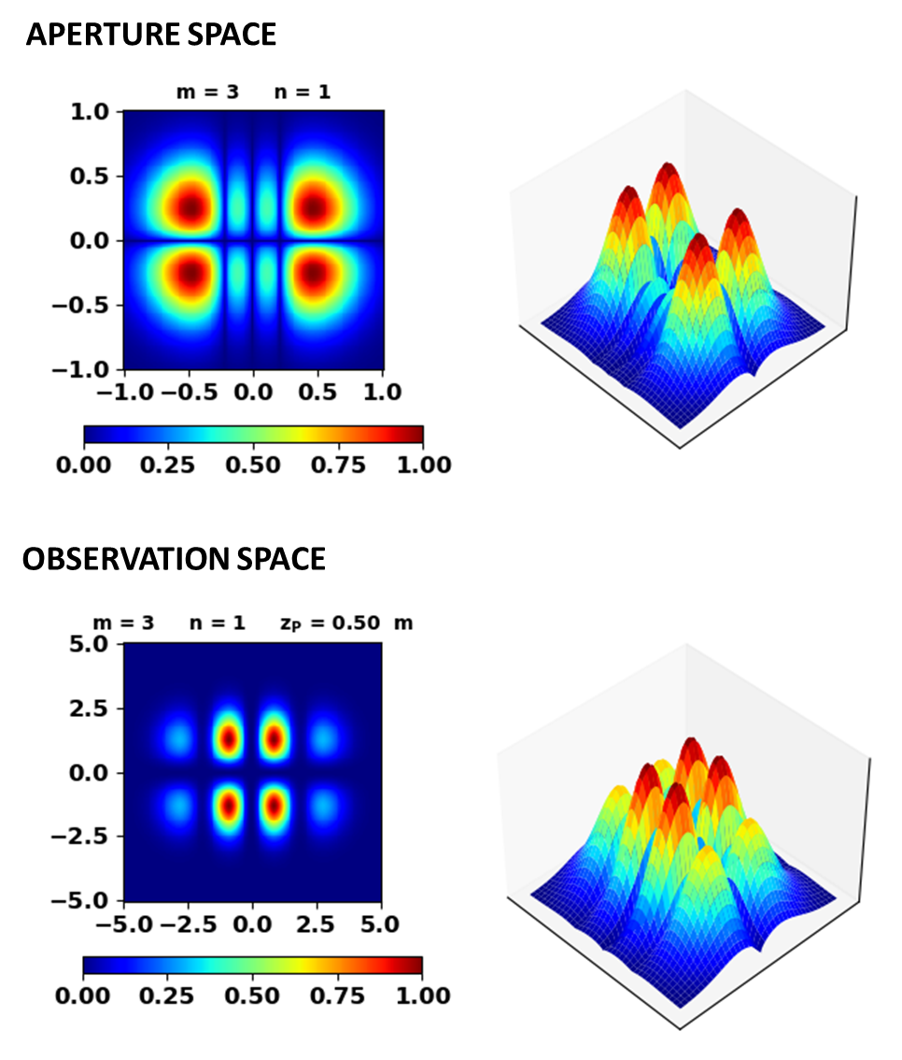

**TEM32**

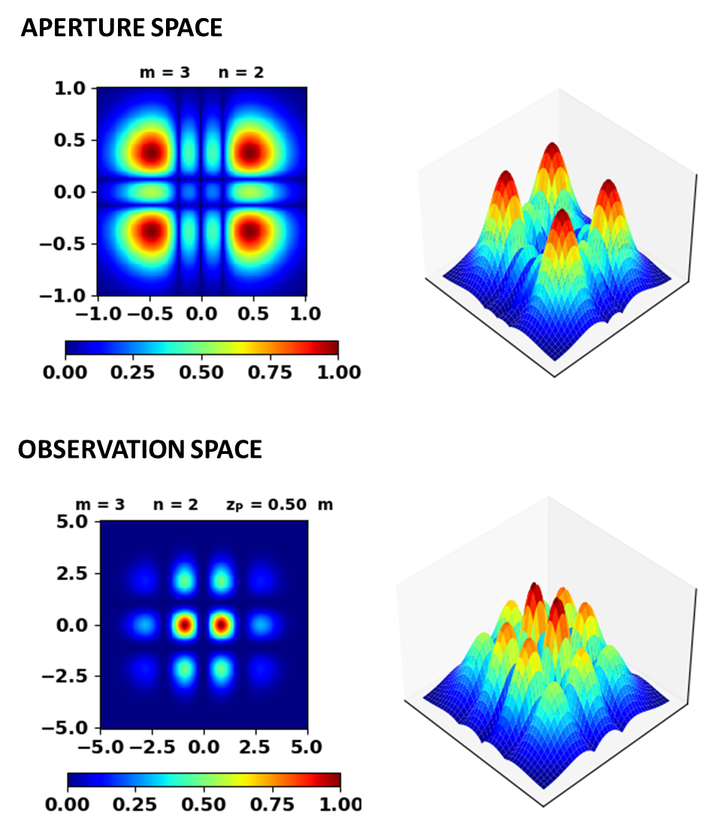

**TEM33**

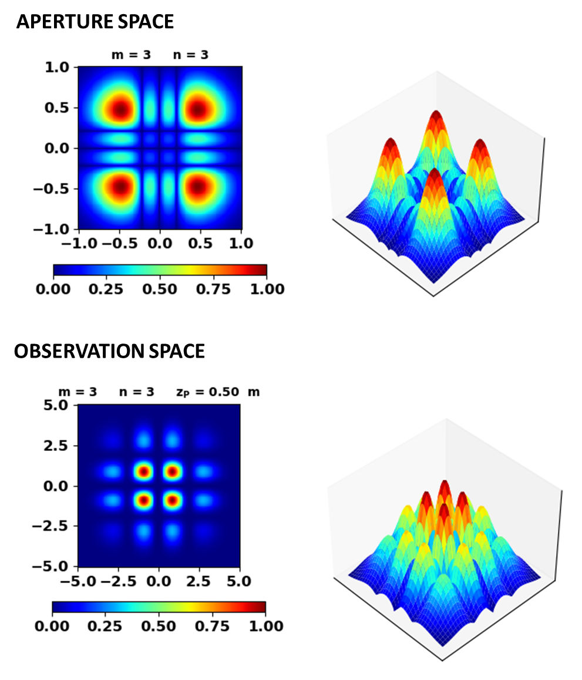

**VARIATION OF IRRADIANCE PATTERN WITH *zP***

**TEM00 Gaussian beam**

**APERTURE SPACE**

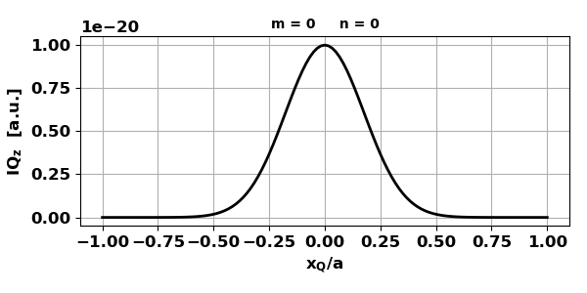

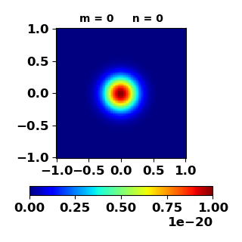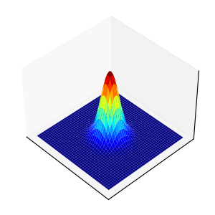

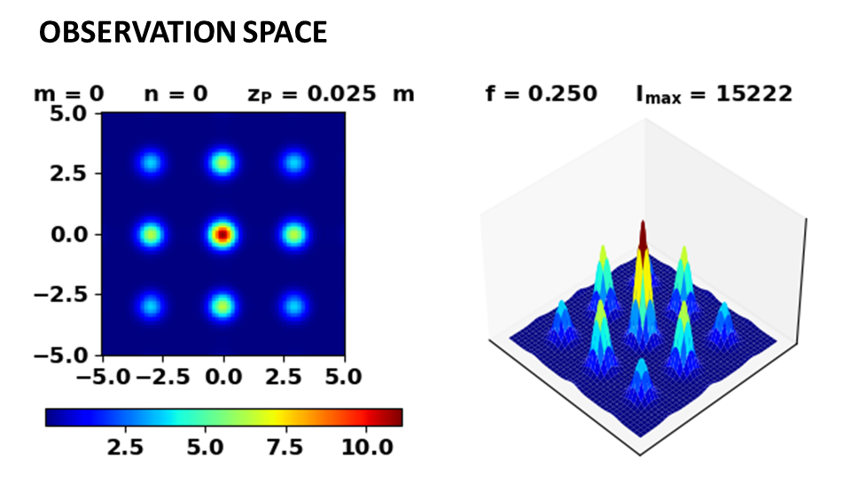

When the observation plane is very close to the aperture, many peaks in the irradiance occur because of the construcntive and destructive interference of the ligh from different parts of the aperture (Fresnel diffraction).

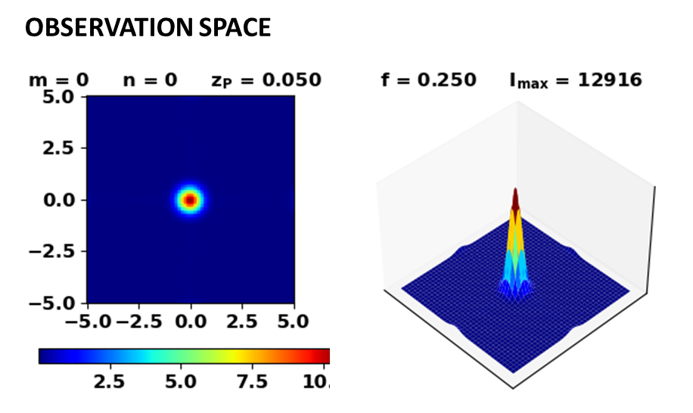

For distances between the aperture and observation plane greater than about 0.05 m , the irradiance profile is toa good approximation Gaussian.

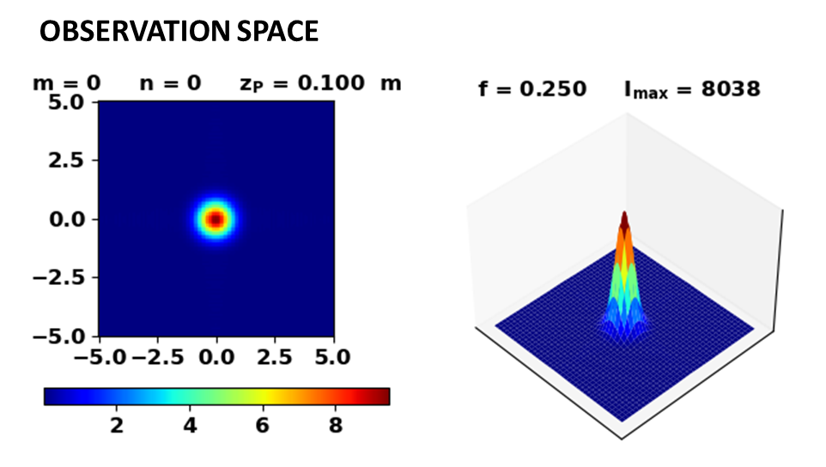

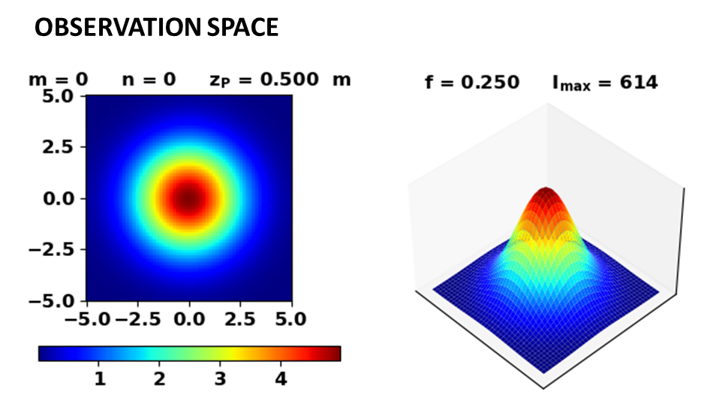

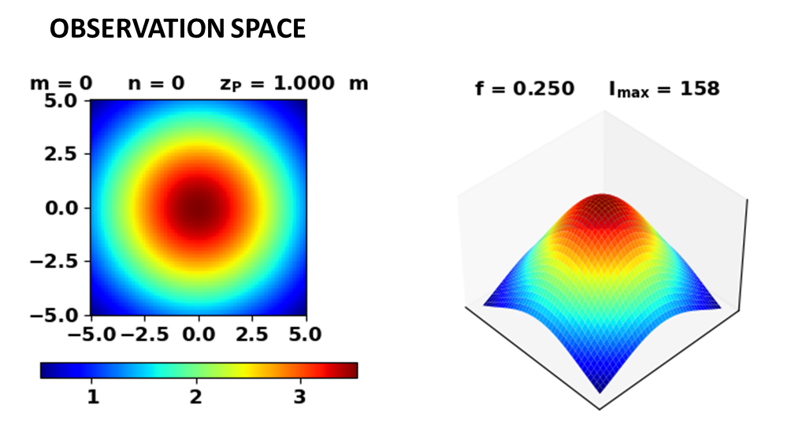

As the observation screen moves further away from the aperture, the Gaussian profile of the irradiance is maintained as it spreads. For large distances between the aperture and observation screen, the aperture behaves like a point source and the inverse square law is valid.

|  |  |  |  |
| --- | --- | --- | --- |
| [m] | 0.50 | 1.00 | 2.00 |
| [a.u.] | 614 | 158 | 40 |
|  |  | 614/4 = 153 | 158/4 = 40 |

**HIGHER ORDER MODE TEM32**

**APERTURE SPACE**

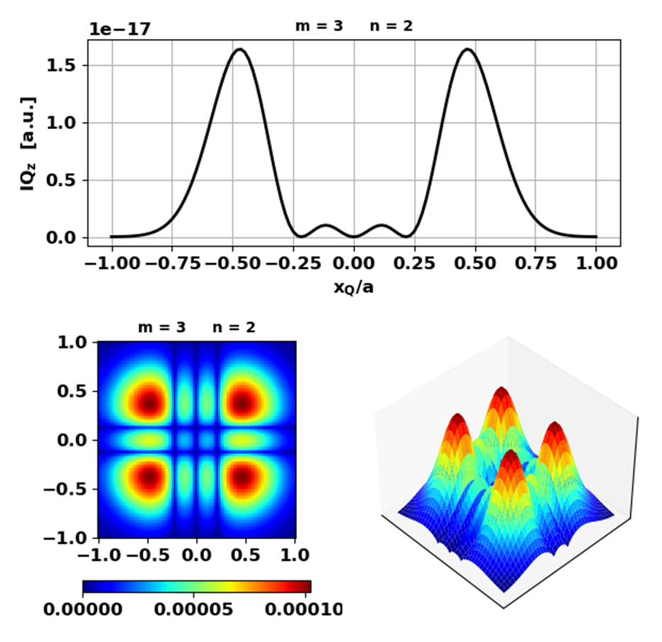

Scaling factor *f* = 0.25.

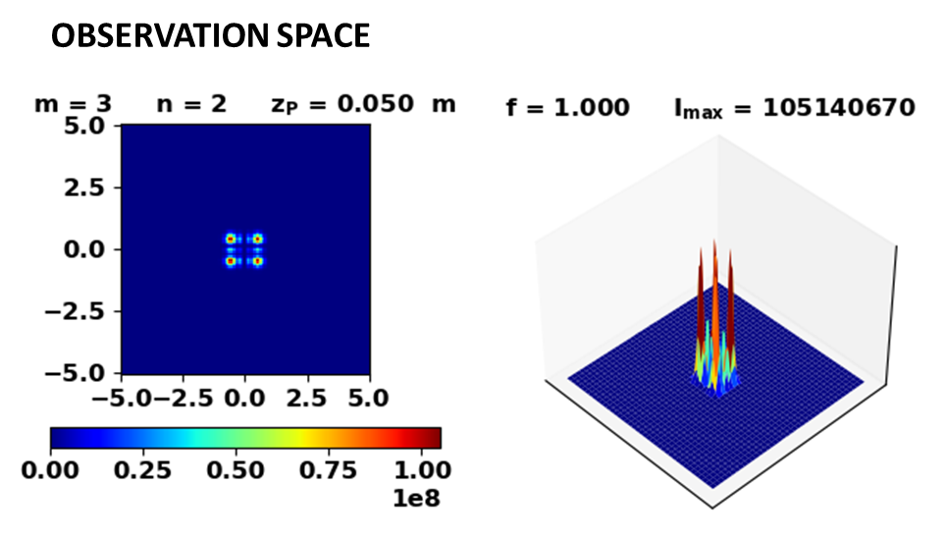

There are four peaks are in the observation plane and the irradiance profile is similar to the aperture irradiance profile. However, as the distances between the aperture and observation plane increases, two dominant peaks are found along the X axis.

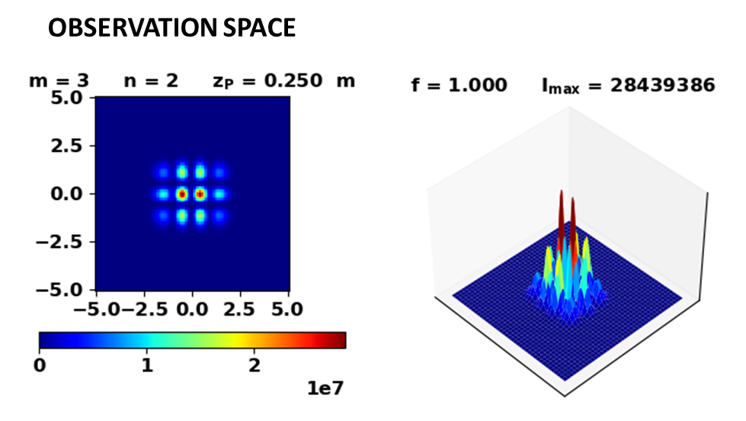

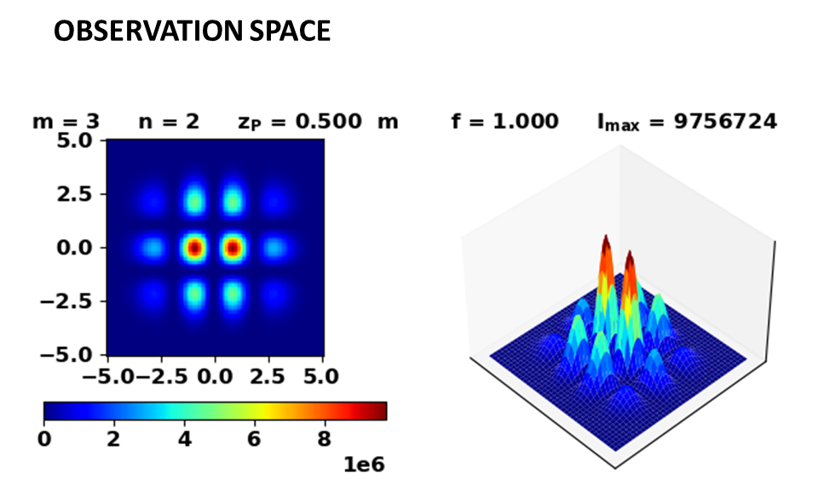

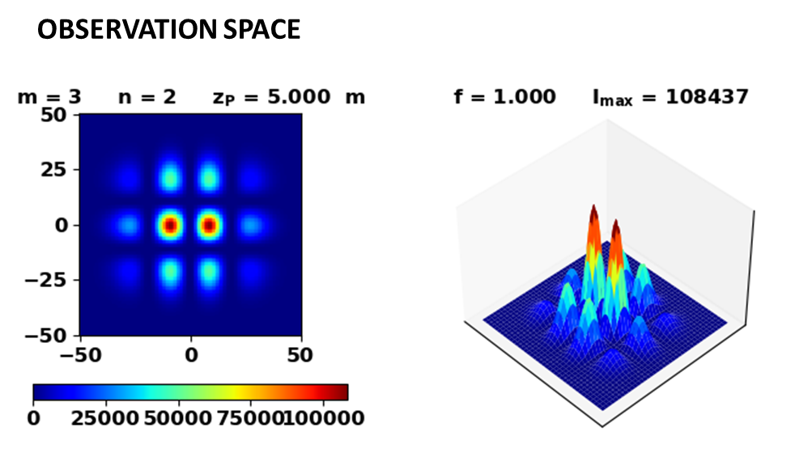

Even for large values of *zP*, the two predominant peaks along X axis persist and the irradiance profile does not change.